Ken Daniels and the Queen "Kiddo Project"
Dan Lago, Ashley and Joe Mick, and Fred Fisher
8-14-2022
Ken Daniels and the Daniels Family Cutlery Company bought Queen Cutlery in Titusville, PA, in 2012, and made knives in the famous cutlery factory for five years till they closed their doors forever in early January 2018. This article is about one very nice and praiseworthy thing Ken did during those years – "The Kiddo Project." Ken brought much innovation to Queen in his years as owner, for example adding new knife patterns and increasing the amount of fine stag handles Queen produced. This is simply a story of a great idea by a dedicated owner and knife collector.
Ken Daniels grew out of a multigenerational knife collecting family and consistently worked very hard to instill knife collecting and the knife business into his own children and grandchildren. He recognized that one must grow up with knives to have an interest and knowledge about the diverse world of knives. How many times have each of us seen longtime collectors of knives face the sad fact that their offspring have absolutely NO INTEREST in the collections they have amassed and no interest in investing the hours, years, and money, in learning about knives?
The old, grey haired, or bald, men and women who carried and used knives as children recognize that times change and they must either leave their collections as a burden to surviving family who care nothing for them. Or they must face the sad, difficult task of selling off their lifetime hobby (and major investment) to buyers who offer, at best, 40-50% of the value of their knives.
Ken Daniels wanted to tackle this issue at a company level, and began the Kiddo Project as a direct and practical response to these problems. The plan was simple: Encourage kids to attend knife shows and acquire knives (for NO COST) with older family members. Giving away Queen-made knives was a very heavy cost for any cutlery and was not done without a lot of thought. In fact, while Ken was the majority owner of Queen Cutlery Company, he received no salary as owner. His ONLY compensation was in knives which he gave away freely to children. He felt that strongly that children needed to start early if they were going to have a life long affection and knowledge of knives, since that is how most of us started.
So, beginning in 2015, Ken developed the Kiddo Project, summarized in a poster used in their last two catalogs (Figure 1). Figure 2 included some images of children and Ken that the company also used in their last two catalogs. All ages were encouraged, from little babies who might not remember how they got the knife, but at least they might have an archival memory of being held by attentive parents while they were surrounded by thousands of knives of great interest to their parents. Who can know what the long-term outcomes of the short-lived Kiddo Project were. It probably did not help the bottom line of Queen Cutlery finances, but depending on how parents have followed up with the effort, it might have been very helpful to familial interest in collecting knives and preserving a sense of Americana history.

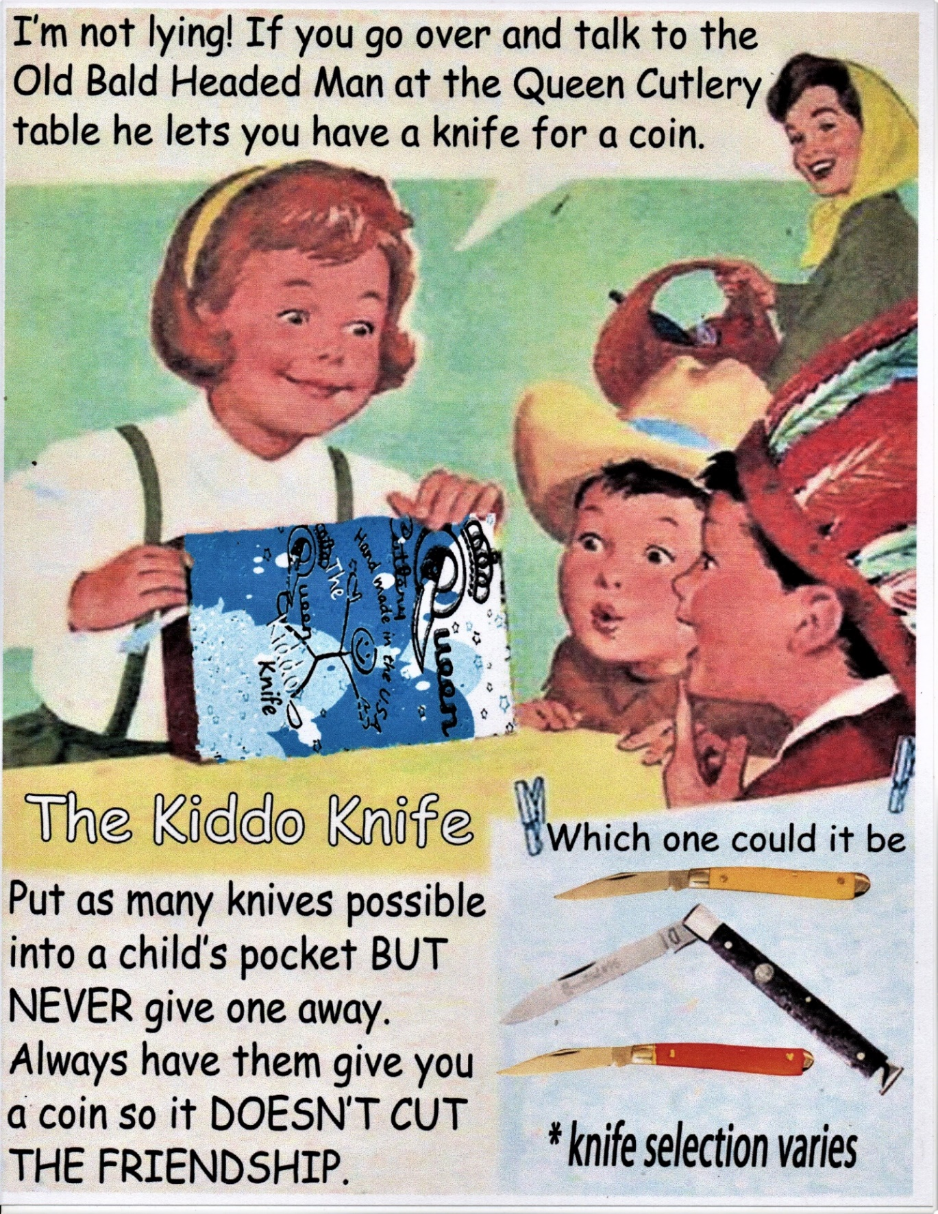
Figure 1. Kiddo Poster used in 2015 through 2017 (and in both 2016-2017 catalogs). The knife was FREE, but the parent had to be there to approve, and the COIN was a very traditional approach to giving knives among friends – So the knife was not supposed to cut the friendship.
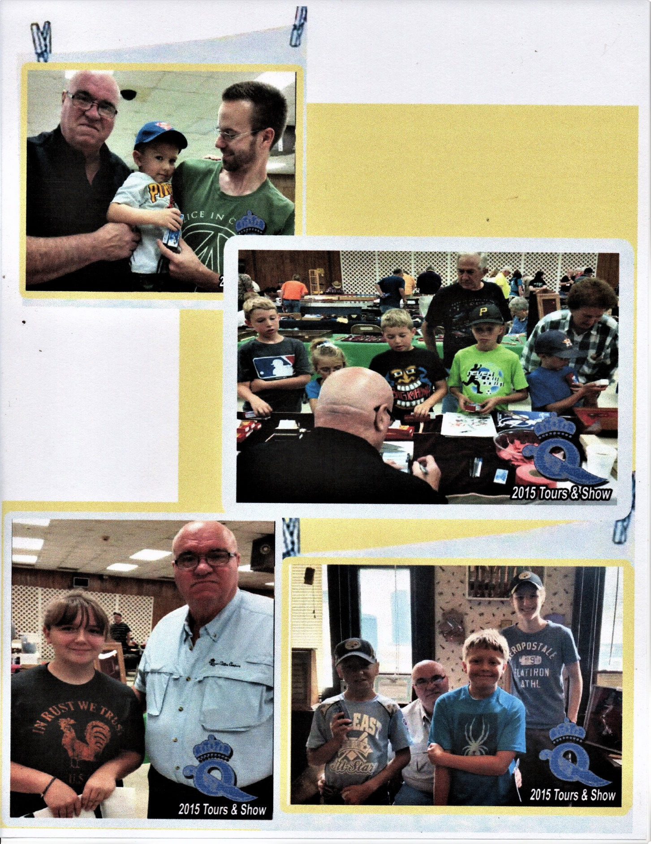
Figure 2. Photos from 2016 and 2017 Queen Catalog with children receiving a Kiddo knife from Ken Daniels. There is no record of how many knives he gave away, but it was MANY!
The three knives in the program shown in Figure 1, were a single blade #14 “peanut” in amber or red Delrin and a black Delrin small one-blade Doctors knife. However, the program was wider than that, as shown in Figure 3, with a variety of patterns and handles. As far as we know, all patterns were reduced to single blade knives, probably a reasonable safety issue, reducing risk for younger users from cuts while learning to manage opening both blades at the same time – how many of us have been nicked by the secondary blade! All the tang stamps show Daniels Family Cutlery and most that we have seen were in stainless – a very nice choice for a child’s collection that might be stored for long times.
As can be seen in Figures 3 and 4, each knife was presented in a Kiddo black two-piece box, or the white one-piece box seen in the company’s last year. Each was dated and manually signed by Ken Daniels. These were not merely toys; they were obviously treated as a beginning collector asset. 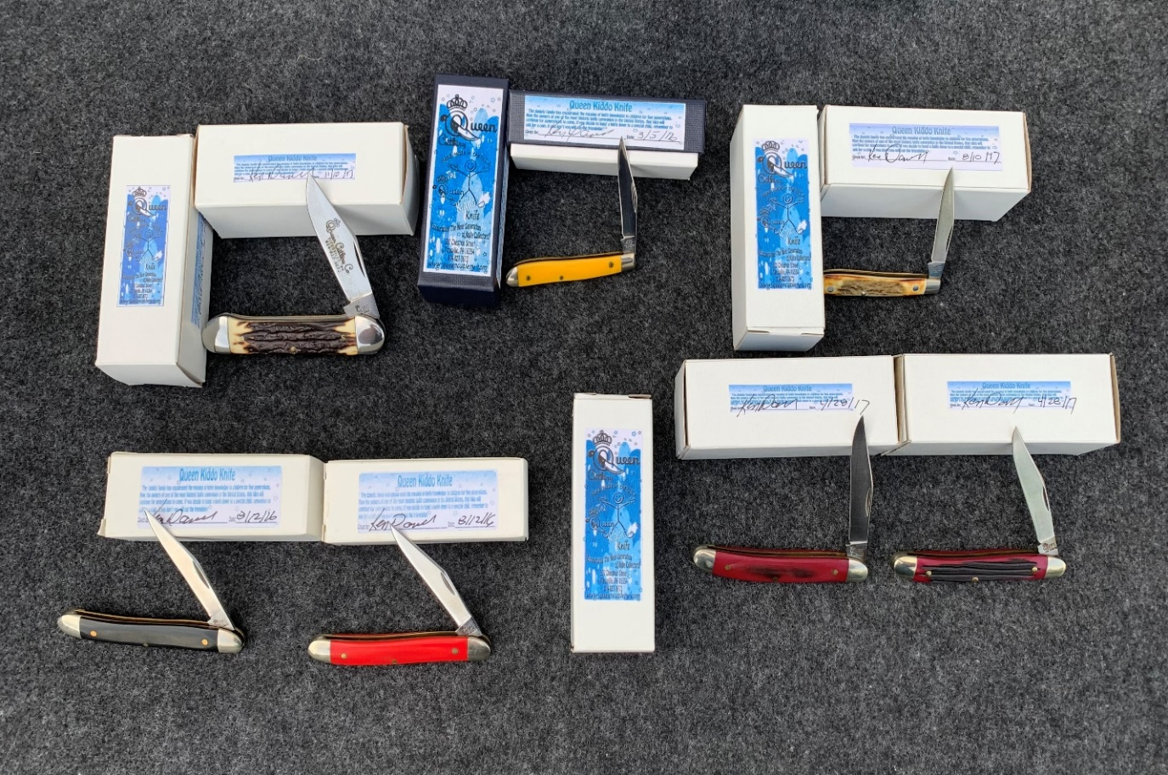
Figure 3. Knives given to two children who regularly attended knife shows with their parents as part of the Kiddo Project. The variety of knives and handle materials suggest that someday in the future a “complete” collection of Kiddo knives would be a very interesting, collectable group. Name another cutlery company who has made such a collection? (© Mick family photograph)
Easily our favorite knife of this set is the very nice Schatt & Morgan tang stamp on a stag-handled peanut, seen in Figure 4. This is a very generous offering to a child who one day may recognize what he or she received from “The old bald-headed man.”
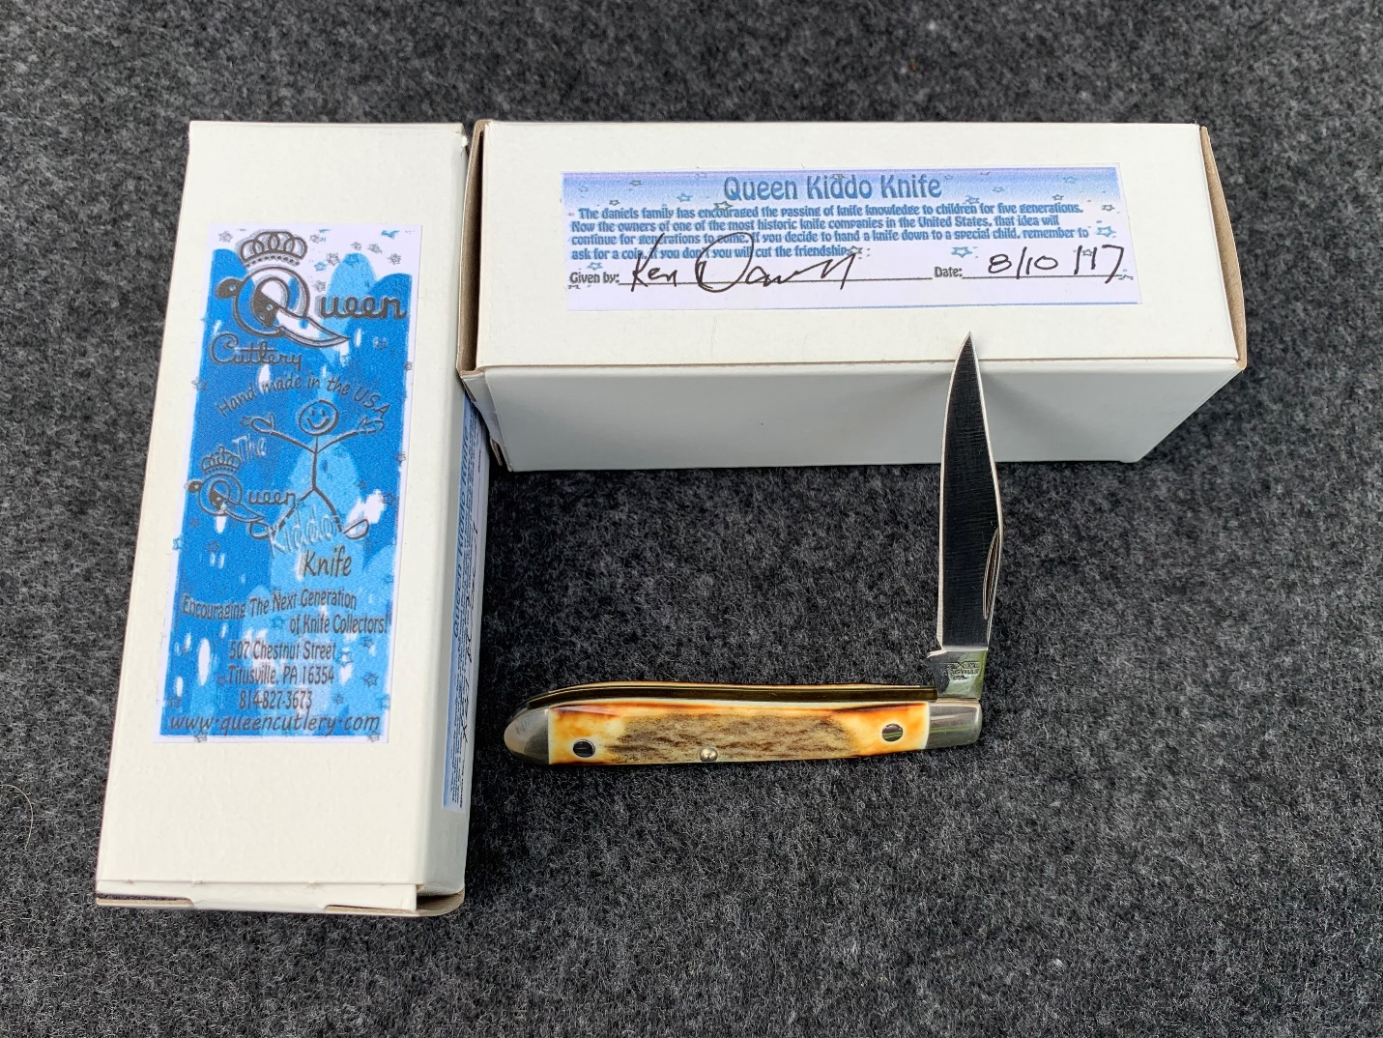
Figure 4. A Stag handled Peanut model #14, with a Schatt & Morgan tang stamp, given to a child for free as part of the Kiddo Project. (© Mick family photograph)
Queen and Ken continued the program in 2016 and 2017, profiling it in their catalogs and a special table where Ken handed out knives at each knife show they did through the company’s last three years. If you had a chance, you would have seen how interested and excited these children were to get a knife in a real Queen box. There were MANY happy interactions at Ken’s table! And it was very clear that Ken was very happy at those times – not concerned with business issues, but watching the hearts and minds of kids liking a new knife – of ADDING a knife to their collection.

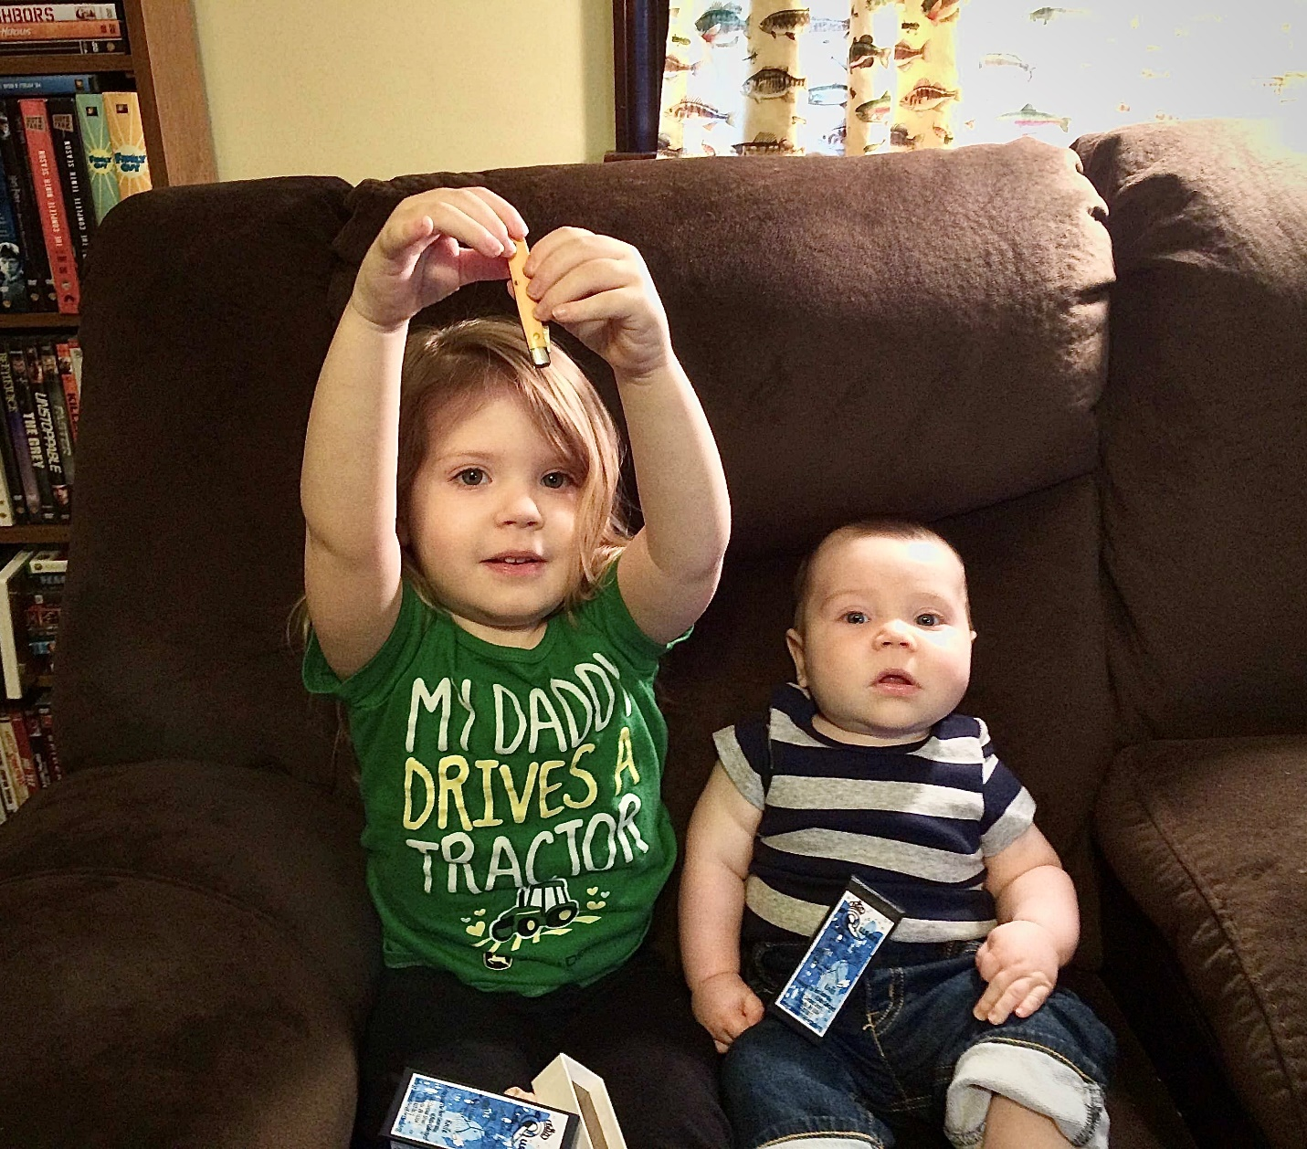
Figure 5. Shelby (age 3) and Cooper Mick (5 months) with their first Kiddo knives in 2015. These are the children of Ashley and Joe Mick, who visited the Queen table at local knife shows. Cooper couldn’t yet walk when he got is first kiddo knife, but he did get an early start on building his knife collection. For the record, they still are active participants of current knife shows with their parents. (© Mick family photograph)
Our message to knife owners, based on Ken’s approach, is simple; involve your children and grandchildren in your interest in knives. Give knives, let them handle and study knives in your collection, take them to knife shows, let them develop skill in using knives and praise their growing interest in working with knives. Document your knife collection so they know what you like and what you have. While modern knife interest has been largely converted to a dollars and cents perspective, it is still mostly an emotional issue and that is what Ken Daniels was pointing out in the Kiddo Project.
References:
Queen Cutlery Company (2016 and 2017) Annual Catalog. (out of print-only in private Collections)

